**SOLANO COMMUNITY COLLEGE**

**MT 162, ROBOTICS**

Fall, 2018

SOLANO COMMUNITY COLLEGE

ROBOTIC SYSTEMS MT-162

**LAB 12: Macros**

**Catharine Crayne**

11/16/18

**OBJECTIVE**:

1. To learn how to create a macro program and set it up to run from Teach Pendant, Digital Input, and the Manual Functions Screen.

**GROUP MEMBERS**

*Dianne Halsey, Jerry Livingston, Alex*

**MATERIALS**: RoboGuide and Laptop, Fanuc Robot or RoboGuide

**PROCEDURE**:

1. Power up the robot controller. Place the robot and pendant in Teach Mode.
2. Create a new program that will be called ZERO_POS. 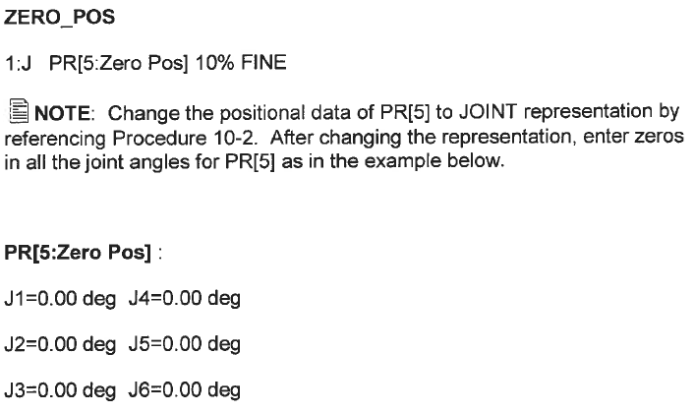
3. Teach the robot to go to position register (5) where all joints are at 0 degrees.
4. Verify that it works.
5. Change the program to a Macro sub type and assign it to the SU key #1.
6. Verify that it works with the SU key.
7. Assign a Macro sub type to one of the earlier programs you wrote, such as Triangle. Assign it to the Manual Functions (MF) screen #4.
8. Now assign a Macro sub type to another on of your earlier programs such as Box. Assign it to DI [109].

**RESULTS - DATA**

Not Applicable for this lab.

**OBSERVATIONS**

Step 2 Step 3

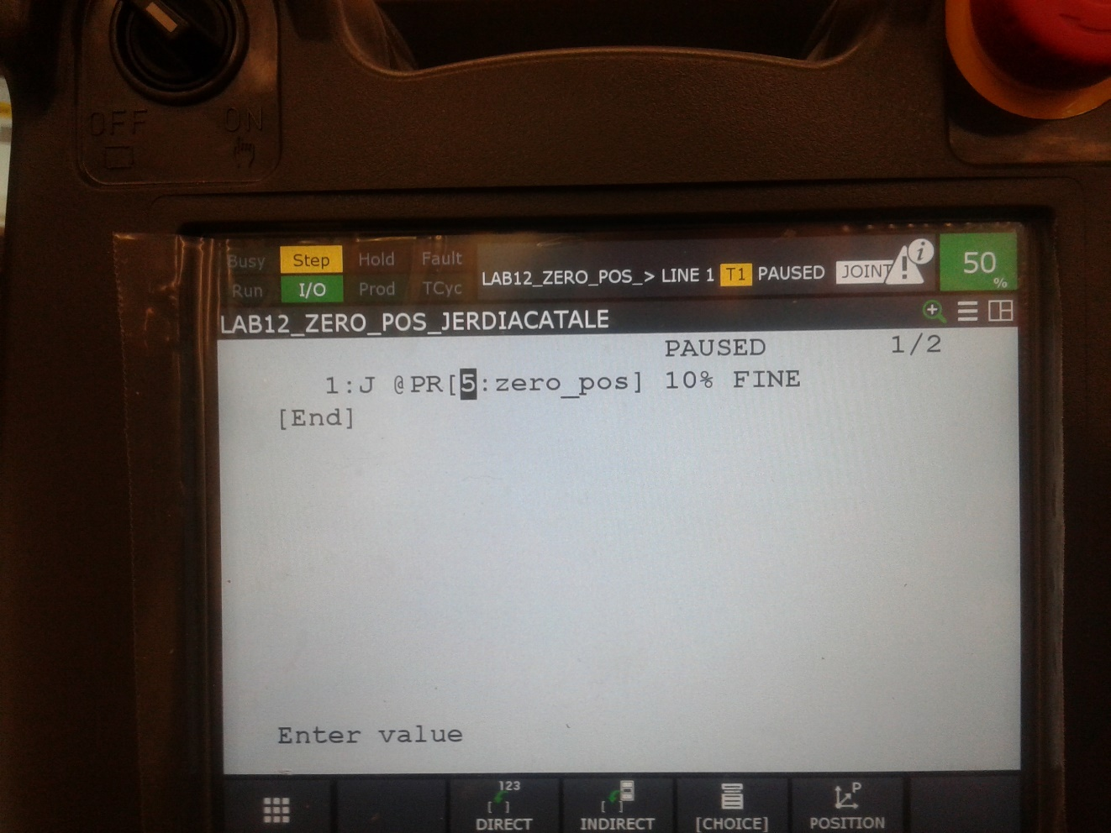 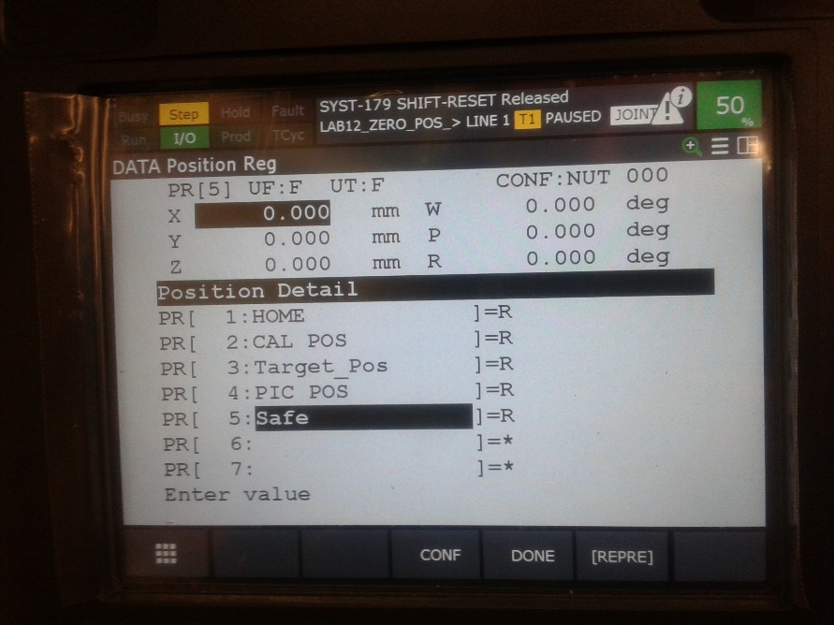

Step 5-6 Step 7

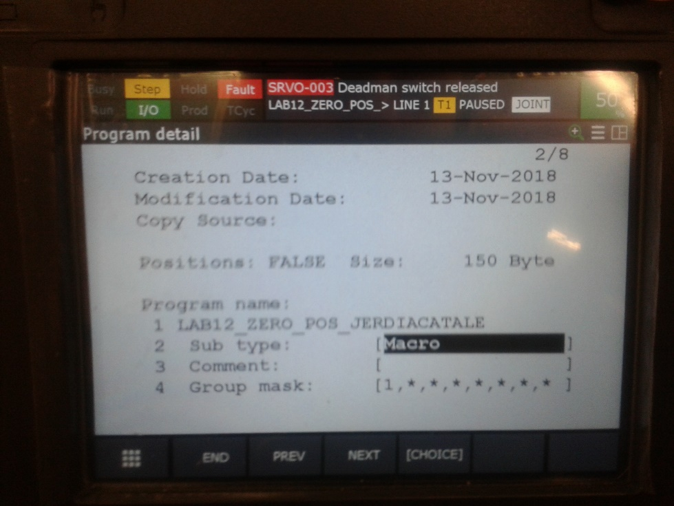 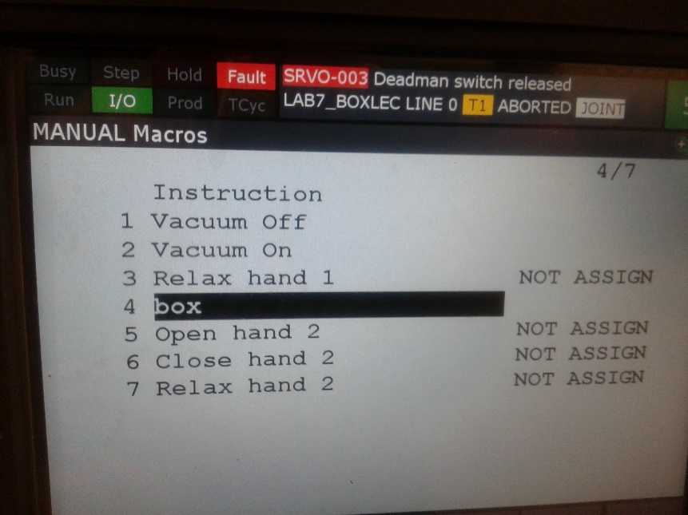

Step 8

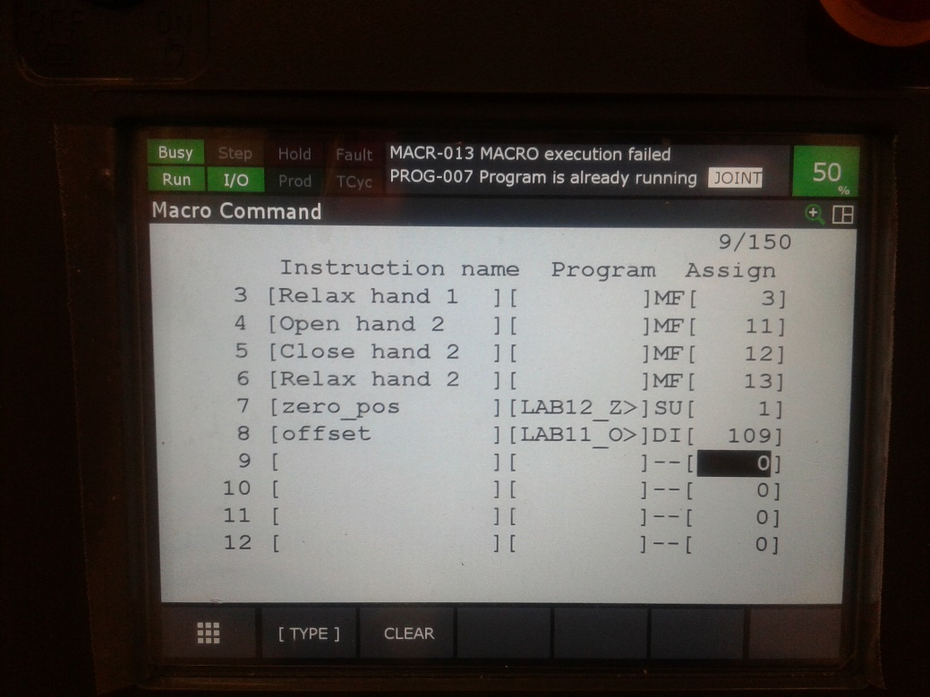

**Step 2 - 8**

/PROG  LAB12_ZERO_POS_JERDIACATALE     Macro

/ATTR

OWNER        = MNEDITOR;

COMMENT        = "";

PROG_SIZE    = 150;

CREATE        = DATE 18-11-13  TIME 20:18:44;

MODIFIED    = DATE 18-11-13  TIME 20:32:40;

FILE_NAME    = ;

VERSION        = 0;

LINE_COUNT    = 1;

MEMORY_SIZE    = 518;

PROTECT        = READ_WRITE;

TCD:  STACK_SIZE    = 0,

     TASK_PRIORITY    = 50,

     TIME_SLICE    = 0,

     BUSY_LAMP_OFF    = 0,

     ABORT_REQUEST    = 0,

     PAUSE_REQUEST    = 0;

DEFAULT_GROUP    = 1,*,*,*,*;

CONTROL_CODE    = 00000000 00000000;

/MN

  1:J PR[5] 10% FINE    ;

/POS

/END

**Analysis Questions:**

1. What are five ways to execute an assigned Macro?

*In Manual Mode you can use the Teach Pendant User Keys (UK/SU) to start the macro. It can also be executed via the Manual Functions Screen (MF).*

*In Automatic Mode, you can execute the macro through the Digital and Robot Inputs (DI/RI). Another option to execute the Macro in Automatic Mode is through the UOP Inputs (UI).*

*Macros can also be executed during the program execution, such as when the Macro instruction is listed within the program (is the actual instruction). Alternatively, the program can place a CALL instruction to the Macro from within the program.*

1. Why can’t your ZERO_POS macro (from step 5) be assigned to User Key 1 (UK[1])?

*Because the ZERO_POS macro was programmed as SU (Shift User) and it would need to be programmed as UK in order to be assigned to UK[1].*